University of Iowa

Grace Trane

Pak Chung Wong

BAIS 6140 Information Visualization

December 12, 2022

**What’s Your Worth?**

**An Investigation into Median Earnings in Iowa through Occupational and Educational Attainment Data**

**Introduction**

My topic outlines gender pay gaps in the United States and assesses gender disparities seen in the past five years. I specifically investigate Iowa as it pertains to the nation’s averages in order to bring further context to the state I grew up in and currently reside. I care about this topic as I am a woman and have always heard about the gender pay gaps, however, previously never investigated the situation in too much detail. In this way it was a highly insightful topic to explore.

On average, women globally are paid about 20% less than men, and at the current rate, it will take 257 years to close the global gender pay gap (United Nations, 2022, para. 12). According to the Pew Research Center, a research institution focused on questions of public policy and national culture, gender pay gaps in the United States have remained relatively stable over the past 15 years, and there are several measurable factors attributed to the pay gap, including educational attainment, occupational segregation, and work experience (Barroso & Brown, 2022, para. 1). The narrowing of the pay gap is attributable in large part to gains women have made in each of these dimensions (Barroso & Brown, 2022, para. 4). Specifically, in the past five years, the full-time, year-round working women has earned 82% of what their male counterparts earned in the United States, and 79% in Iowa (Trane, 2022).

**Data Identification and Exploration**

The data is collected from the United States Census Bureau and represents 2017 – 2021 estimates in two aspects: occupation and educational attainment by sex. The dataset on sex by educational attainment over 2017 – 2021 is representative of the population 25 years and over as documented in Table B15002 (United States Census Bureau (n.d.)). The dataset on occupation by sex and median earnings was collected over 2017 – 2021 and is representative of the full-time, year-round, civilian employed population 16 years and over as documented in Table S2412 (United States Census Bureau (n.d.)).

The Census Bureau defines five encompassing groups of occupations: management, business, science, and arts occupations; natural resources, construction, and maintenance occupations; sales and office occupations; production, transportation, and material moving occupations; and service occupations. Within these groups, there are 25 specific occupations.

**Data Manipulation**

I combined the data from each year into one cohesive dataset for each aspect. I then reformatted column headers for Tableau preparation. Upon upload into Tableau, I joined the two datasets using the ‘Year’ columns as the join key. I also ensured the correct data type labels for each column.

I created several calculated fields within Tableau. “Average IA/US Median Pay,” which divides two columns: “IA-Median earnings (dollars)” and “US-Median earnings (dollars),” to get a percentage of Iowa earnings compared to the U.S. This calculated field was used in Figure 1 as a text display to help illustrate differences between Iowa and U.S. median pay. I also created the calculated field “Iowa, 100%,” that calculated if the female earnings were above male earnings, and if so, highlighted those occupations in pink on an animated bar chart. This is illustrated in Figure 9 and Figure 10. Lastly, I created “IA-female/male educational attainment,” which was used in Figure 11. This calculation divided female educational attainment rates by male to get a relative percentage of how females compared to males in obtaining specific educational markers.

**Visualizations and Results**

In the United States, the median earnings for a full-time, year-round, civilian employee in 2021 were $54,330. Similarly, the median earnings in Iowa were $51,069. Figure 1 displays a bar chart of median earnings in the five occupational groups for Iowa and the U.S, and displays that, on average, Iowa median earnings are 98.6% that of U.S. earnings. This indicates that Iowa follows similar trends in pay to U.S. earnings. The bars are colored by group to easily identify them, and the use of a bar chart allows for quick visual comparisons between U.S. and Iowa earnings.

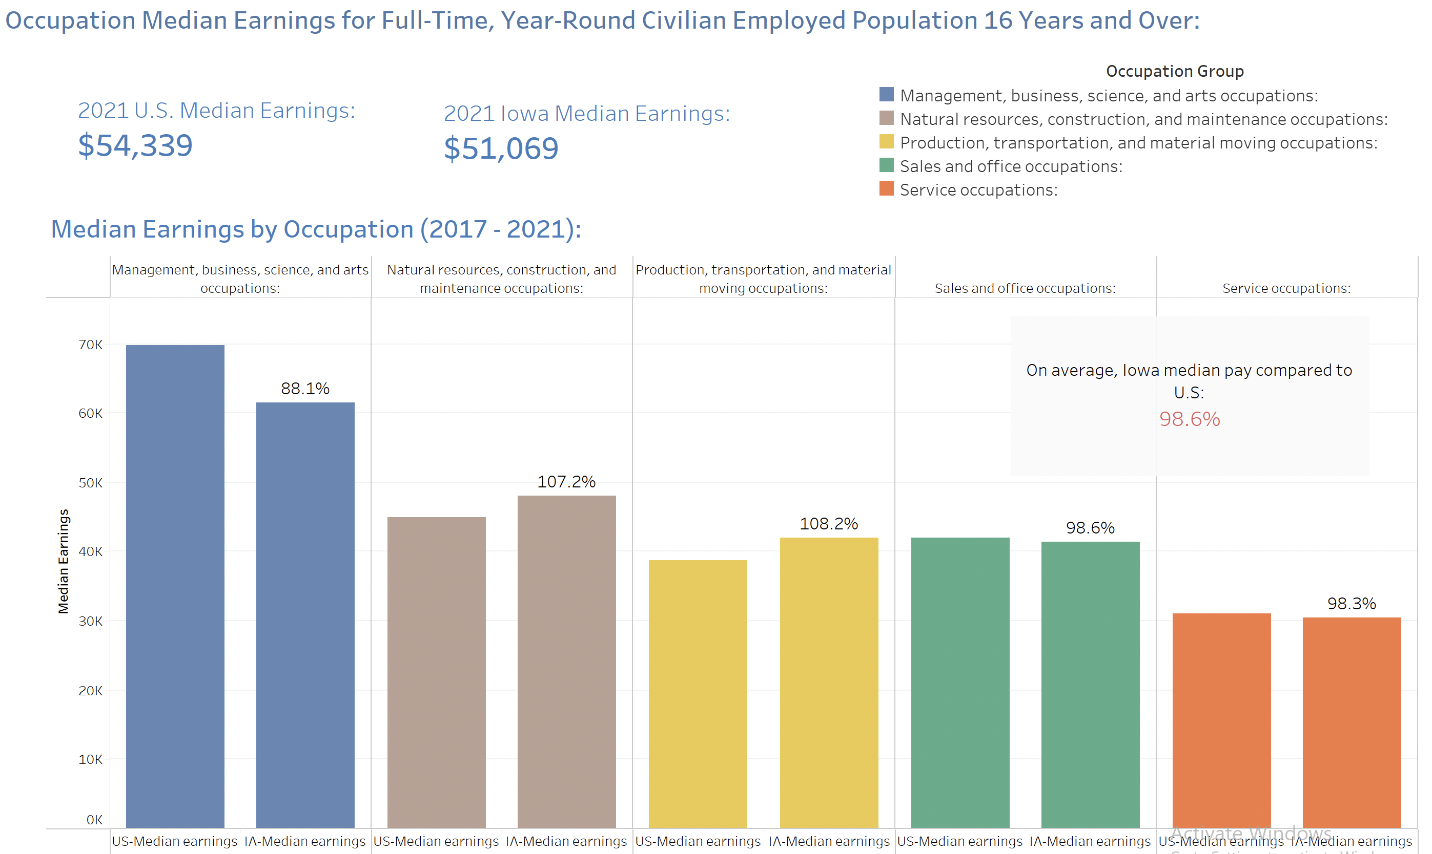

*Figure 1. Median earnings by occupational group dashboard for 2017 – 2021.*

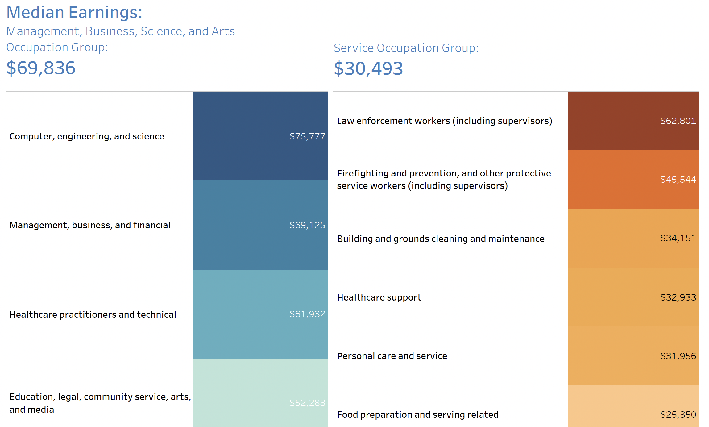Figure 2 examines occupations within the highest and lowest occupational groups over the 2017 – 2021 period. Figure 2 utilizes highlight tables to show the variation of earnings within groups. Of the five groups, the management, business, science, and arts occupations group has the highest median earnings at almost $70,000. Occupations within this category include computer, engineering, and science occupations, management, business, and financial occupations, healthcare practitioners and technical occupations, and education, legal, community service, and media occupations. The service occupation group had the lowest median, at just over $30,000. Occupations in this group include law enforcement workers, firefighting and prevention, building and grounds cleaning, healthcare support, personal care and service, and food preparation and serving related occupations.

*Figure 2. Highest and lowest median earnings of occupational groups (2017 – 2021) dashboard.*

*2a) (left) Highlight table of management, business, science, and arts group. 2b) (right) Highlight table of service group.*

Figure 3 depicts the first in-depth look into female and male median earnings in Iowa. The pie chart in Figure 3a shows the distribution of median pay between the five groups. Figure 3b displays Iowa median earnings by sex and occupation. The darker shades in each bar represent female median earnings, and the lighter shades represent male median earnings. The percentages of female earnings compared to male earnings are displayed along each bar.

There are several insights in Figure 3. The largest difference in earnings is seen in legal occupations, with female earnings at just 52% of male earnings. Female health diagnosing and treating practitioners are at 57% of male earnings. The closest pay gaps are in the healthcare support occupations and life, physical, and social science occupations, at 97% and 91%, respectively.

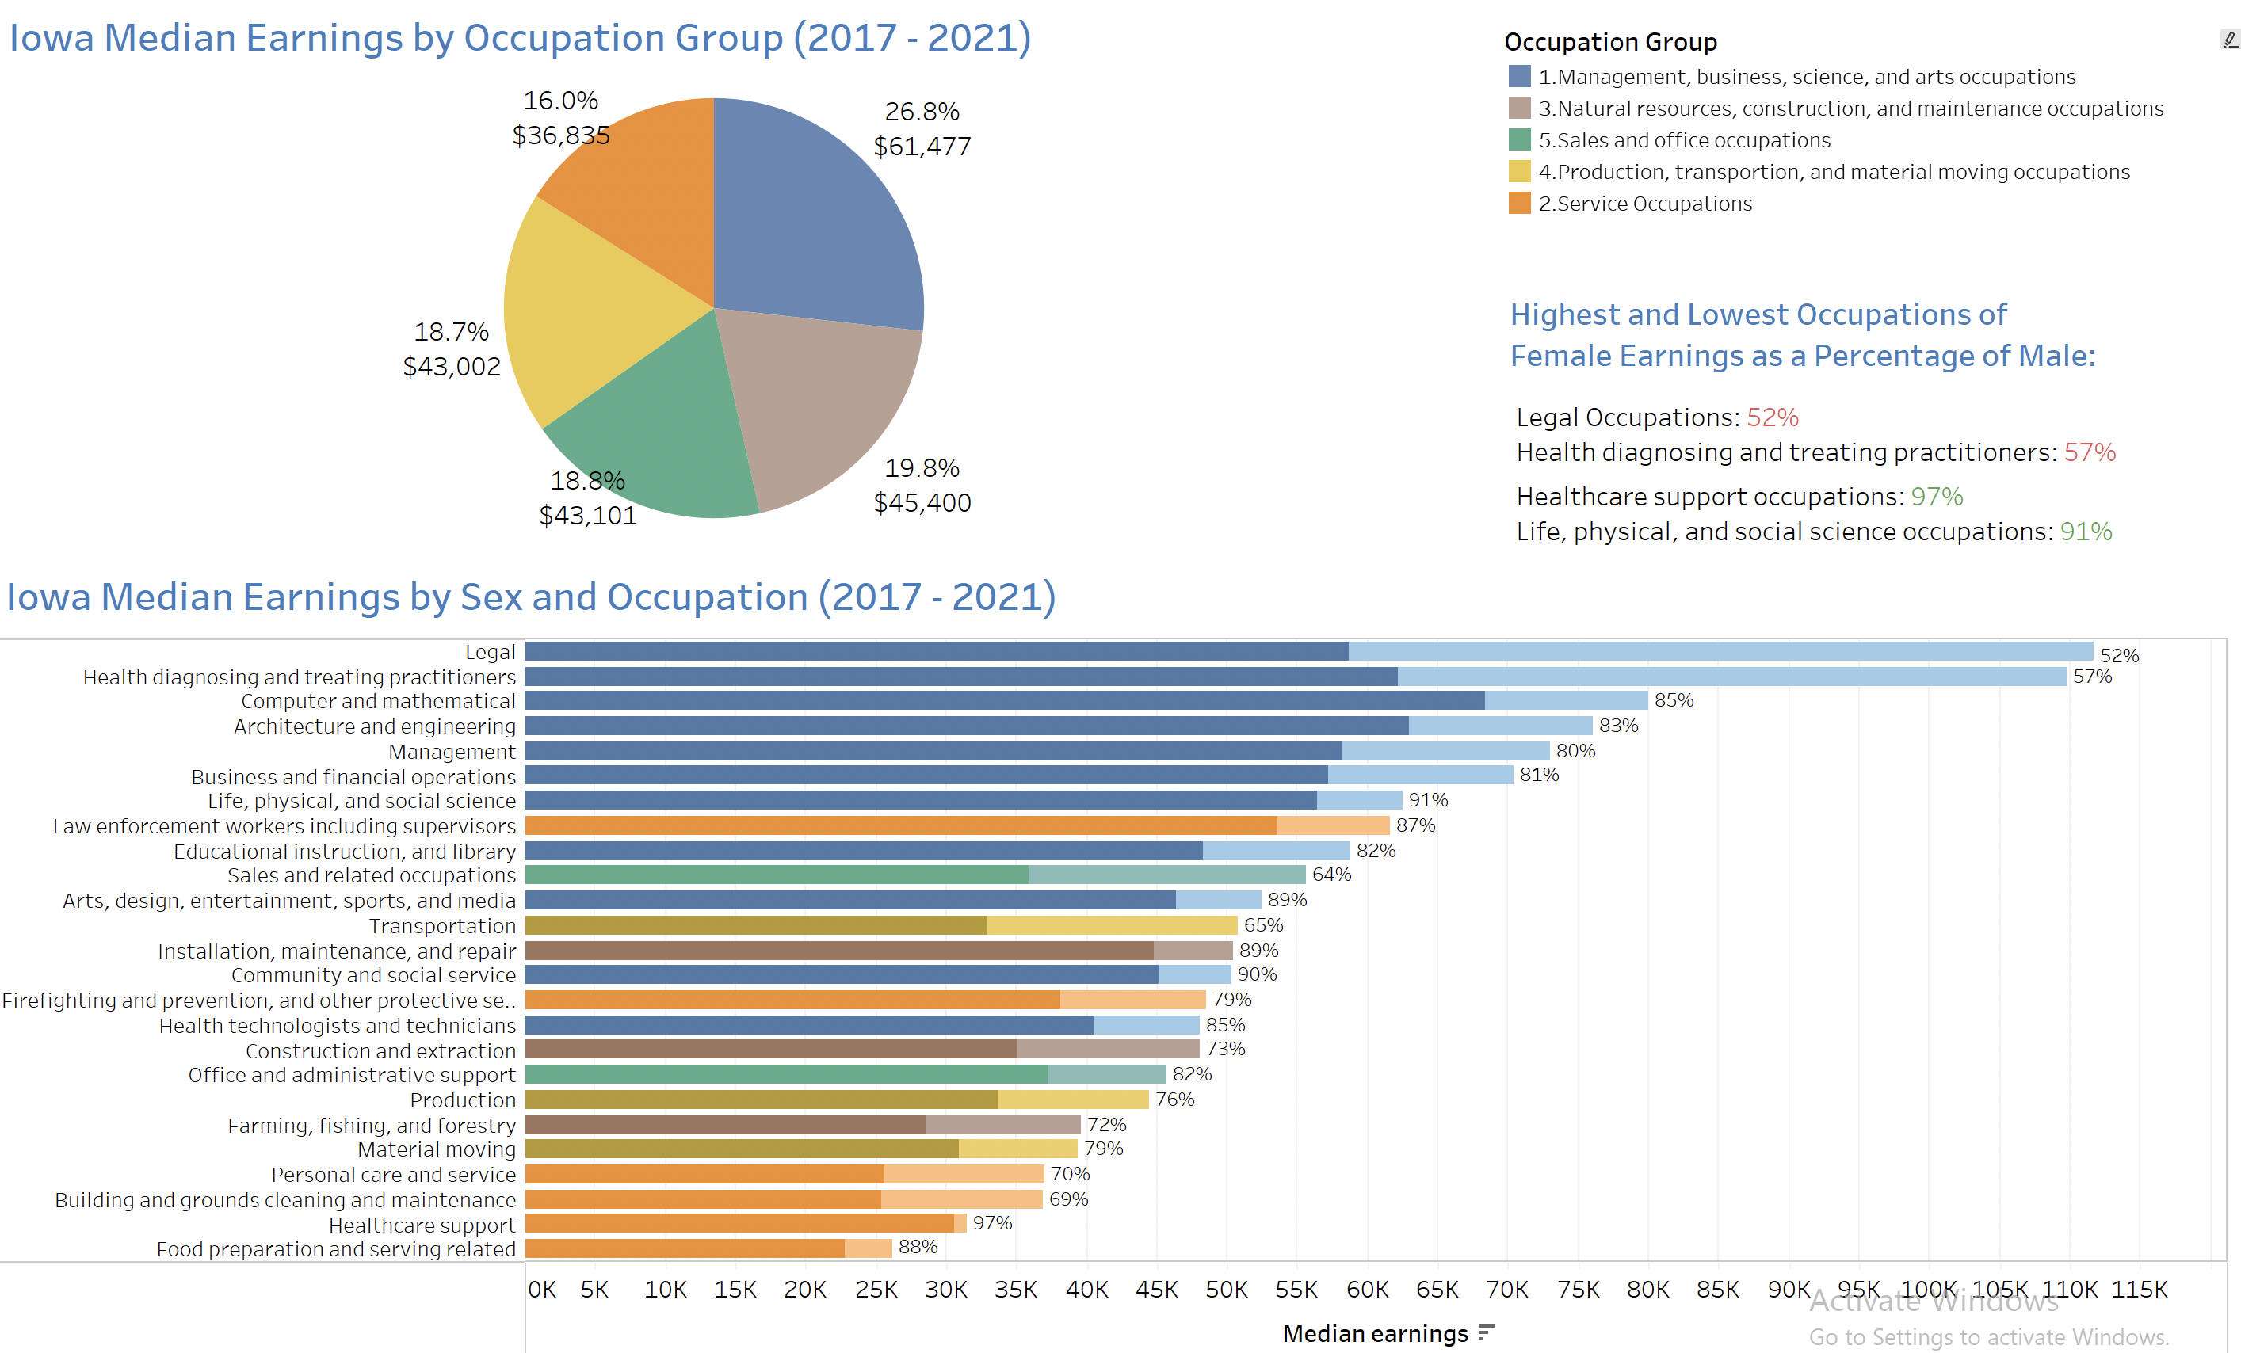Animation actions on this dashboard are detailed in Figure 4 and Figure 5. The highlight action seen in Figure 4 allows for select highlight of each group. For example, when filtering by the sales and office occupations group, one can easily view the median earnings in Iowa in the pie chart and the two corresponding occupations in the bar chart. Filtering seen in Figure 5 displays occupations from the filtered group or groups. For example, the management occupation is filtered, allowing for a more detailed look of occupations in the bar chart.

*Figure 3. Iowa Median Earnings (2017 – 2021) dashboard. 3a) (top) Pie chart of Iowa median earnings by occupation group. 3b) (bottom) Bar chart of Iowa median earnings by sex and occupation.*

Figure 6 displays further pay disparity information by sex. Figures 6a and 6b show the female and male median pay in each occupation group for U.S. and Iowa, respectively. Over the past five years, the U.S. full-time, year-round working women earned 81% of what their male counterparts earned, and females in Iowa earned just 79% of male counterparts. This constitutes 21% less pay, on average, for women working in the same occupations in Iowa.

Figure 6c depicts U.S. median earnings against Iowa, with marks shaped by occupation grouping. Both trendlines show strong, positive correlations and have p-values less than .0001. Thus, Iowa earnings correlate strongly with U.S. earnings. Figure 6c also depicts consistently higher earnings for males, and a much higher slope at $.19 more for every U.S. median dollar earned, versus $.12 for females. Legal occupations are highlighted as an outlier as there is a massive disparity in earnings, with male median earnings at $111,760 and female at $58,762.

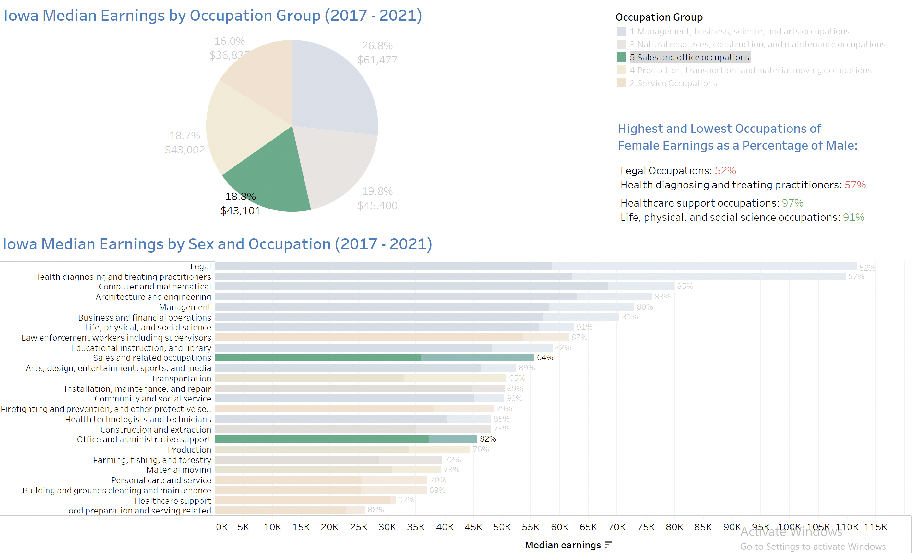

*Figure 4. Highlight action of Figure 3 on sales and office occupations group.*

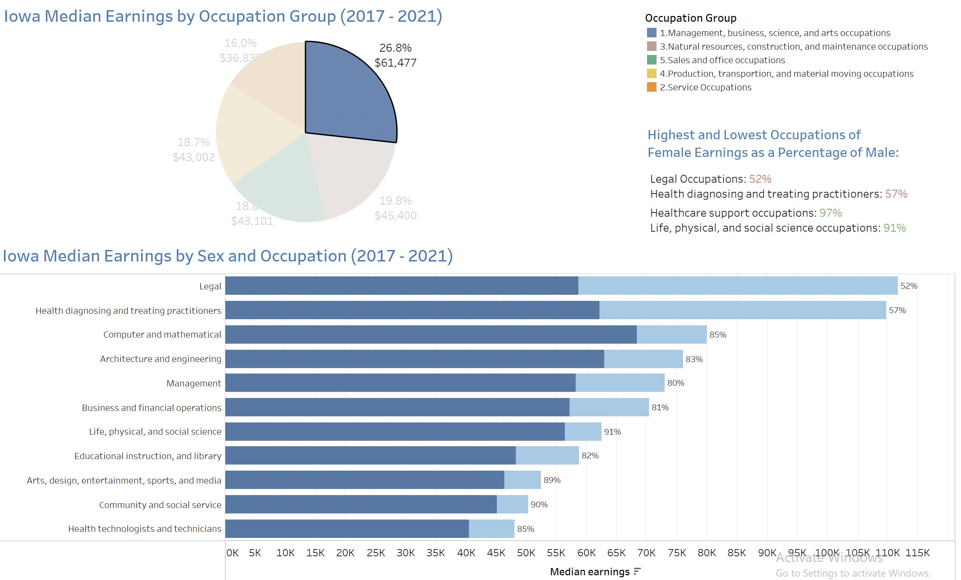*Figure 5. Highlight action of Figure 3 on management occupation group.*

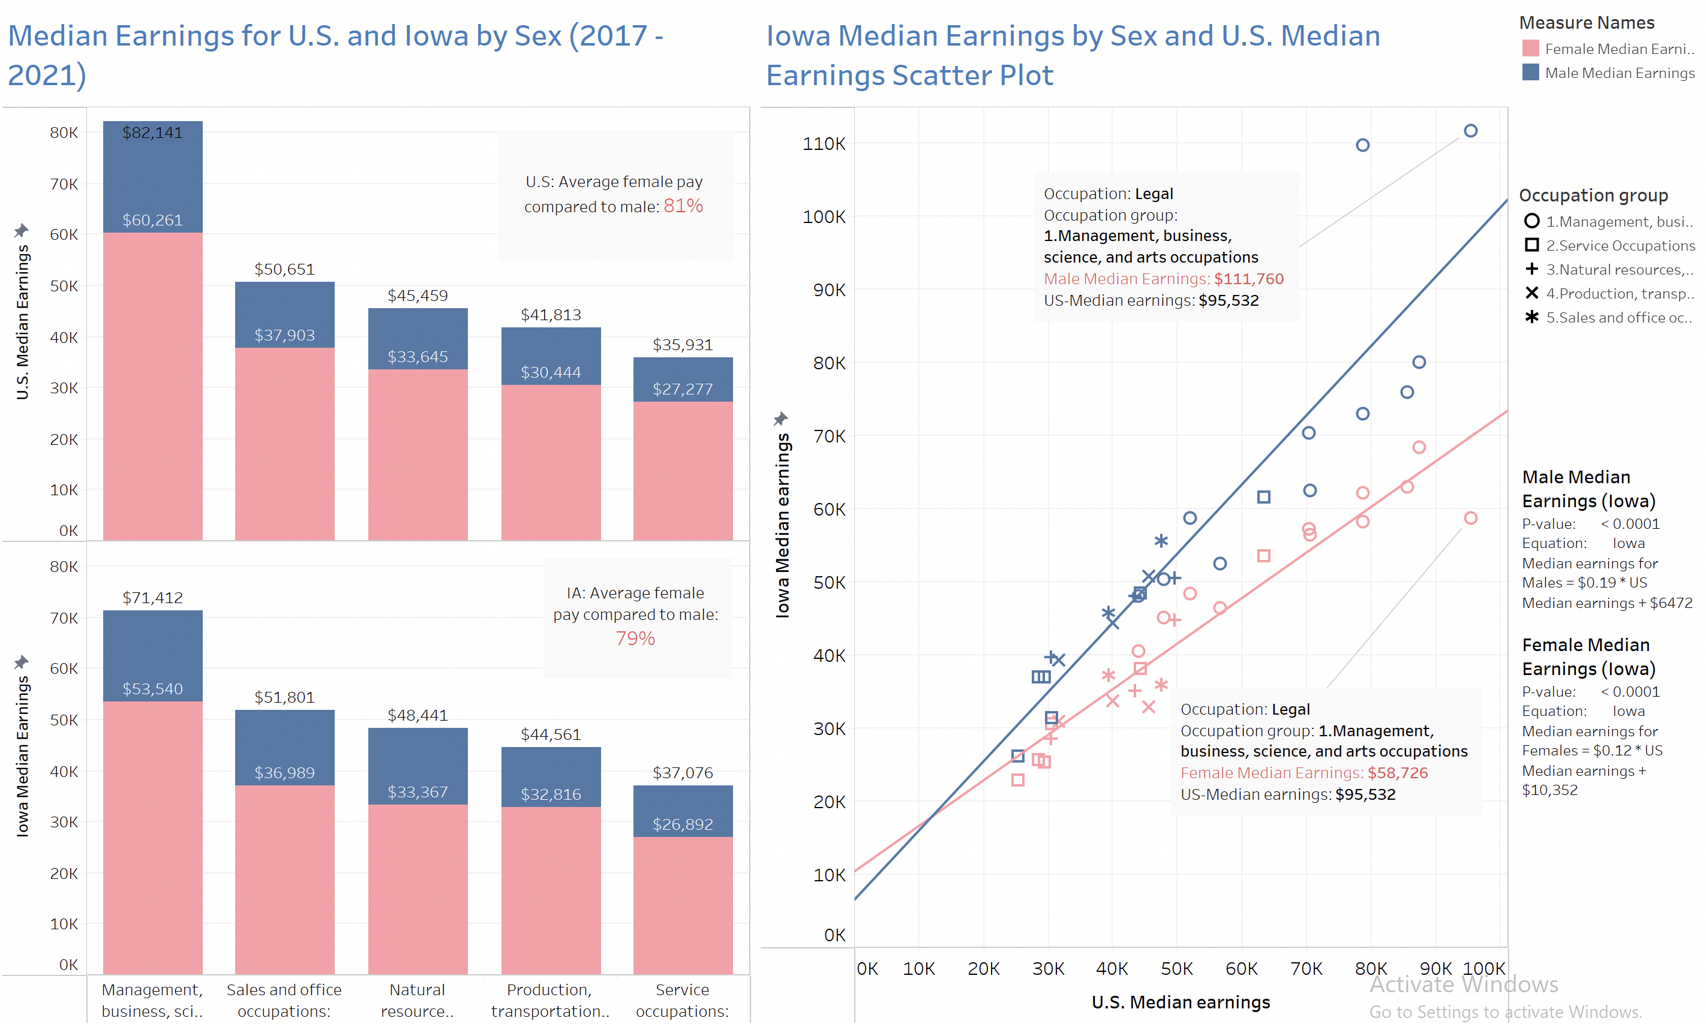

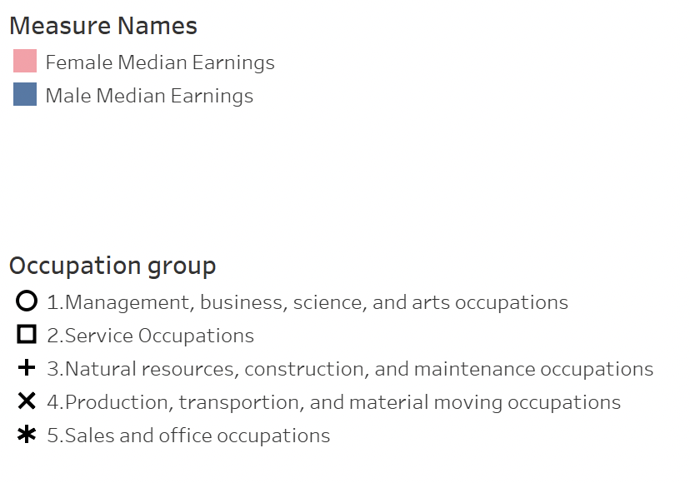**

*Figure 6. Iowa earnings by sex dashboard. 6a) (top, left) Bar chart of U.S. median earnings for occupation groups. 6b) (bottom, left) Iowa median earnings for occupation groups. 6c) (right) Scatter plot of U.S. versus Iowa median earnings.*

Figure 7 helps to define specific occupation outliers in Iowa median earnings by sex. Only 2018 data is displayed in the figure, however, the animation can be played for all five years. Ultimately, Figure 7 shows that there is no observable relationship with a median earnings and relative percentage of pay. In essence, no matter how much someone is making as a full-time worker, females are paid 78.6% that of their male counterparts, as noted by the average line in Figure 7a. The maximum and minimum percentage outliers are also highlighted with text display across each year. These outliers are later examined in Figure 9.

The scatter plot in Figure 7a changes dynamically with the desired year to show the relationship between Iowa median earnings and women’s earnings as a percentage of men’s earnings in Iowa. The marks are colored by occupation group and represent the occupations within each group. The heat map of Figure 7b also changes dynamically by year and displays Iowa median earnings by sex and occupation group. The sizing is ordered by the largest percentage in each occupation group. There is a slider bar to set the desired percentages to view more specific occupational data.

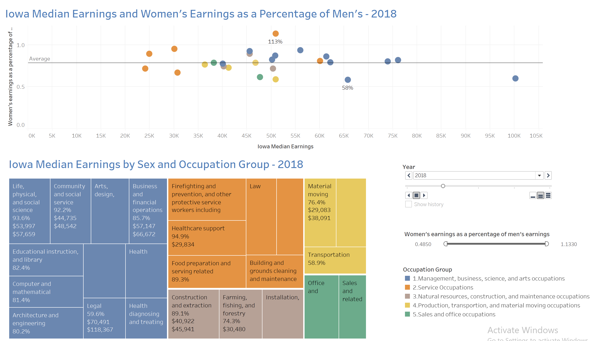Utilizing the slider bar provides further insights into the tree map. For example, Figure 8 displays the occupations with percentages below 70%. The results display five occupations, spanning four out of the five occupational groups: legal occupations, health diagnosing and treating practitioners’ occupations, sales and related occupations, personal care and service occupations, and transportation occupations. Also displayed is the female percentage of earnings, median female earnings, and median male earnings; this provides additional context to the percentage calculation.

*Figure 7. Scatter plot and tree map of Iowa median earnings dashboard. 7a) (top) Scatter plot of Iowa median earnings as they relate to female percentage of pay. 7b) (bottom) Tree map of occupations.*

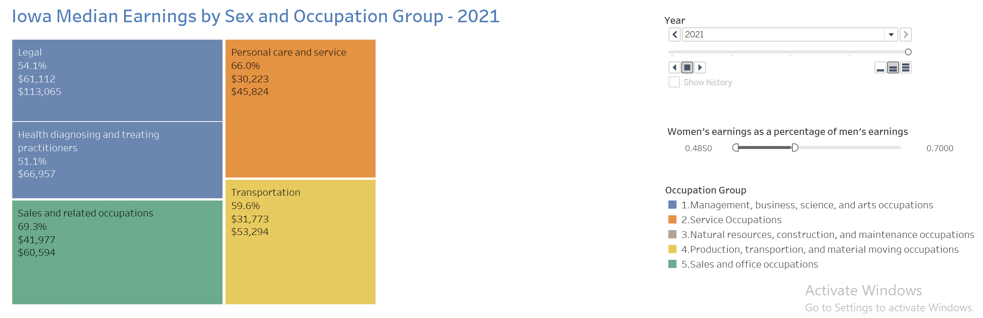



*Figure 8. Filtered tree map of Figure 7b to show female earning percentages below 70% in 2021.*

Figure 9 depicts an animated bar chart of all occupations’ female median earnings as a percentage of male. By creating an animated bar chart visual, a viewer can easily see the fluctuations of median pay across the five years. Only 2017 data is displayed in Figure 9, however, the animation can be played for all five years.

The greatest insight from this visual is that out of the 25 occupations, there are only five instances where females had greater median earnings than their male counterparts; these instances are highlighted as pink bars. Of note, none of these occupations are above 100% across multiple years. Additionally, there are no instances in which women’s earnings were greater than 100% when compared to men’s in the United States across the five-year period.

In 2017, three occupations were above 100% (Fig. 9): installation, maintenance, and repair occupations at 104.0%; life, physical, and social science occupations at 103.4%; and health technologist and technician occupations at 100.1%. In 2018 (Fig. 10a), firefighting and prevention was the only occupation, at 113.0%. In 2019 (Fig. 10b), there was one instance, with healthcare support occupations at 106%. In 2020 (Fig. 10c), there are no instances. In 2021 (Fig. 10d), computer and mathematical occupations are the only instance, at 103.0%.

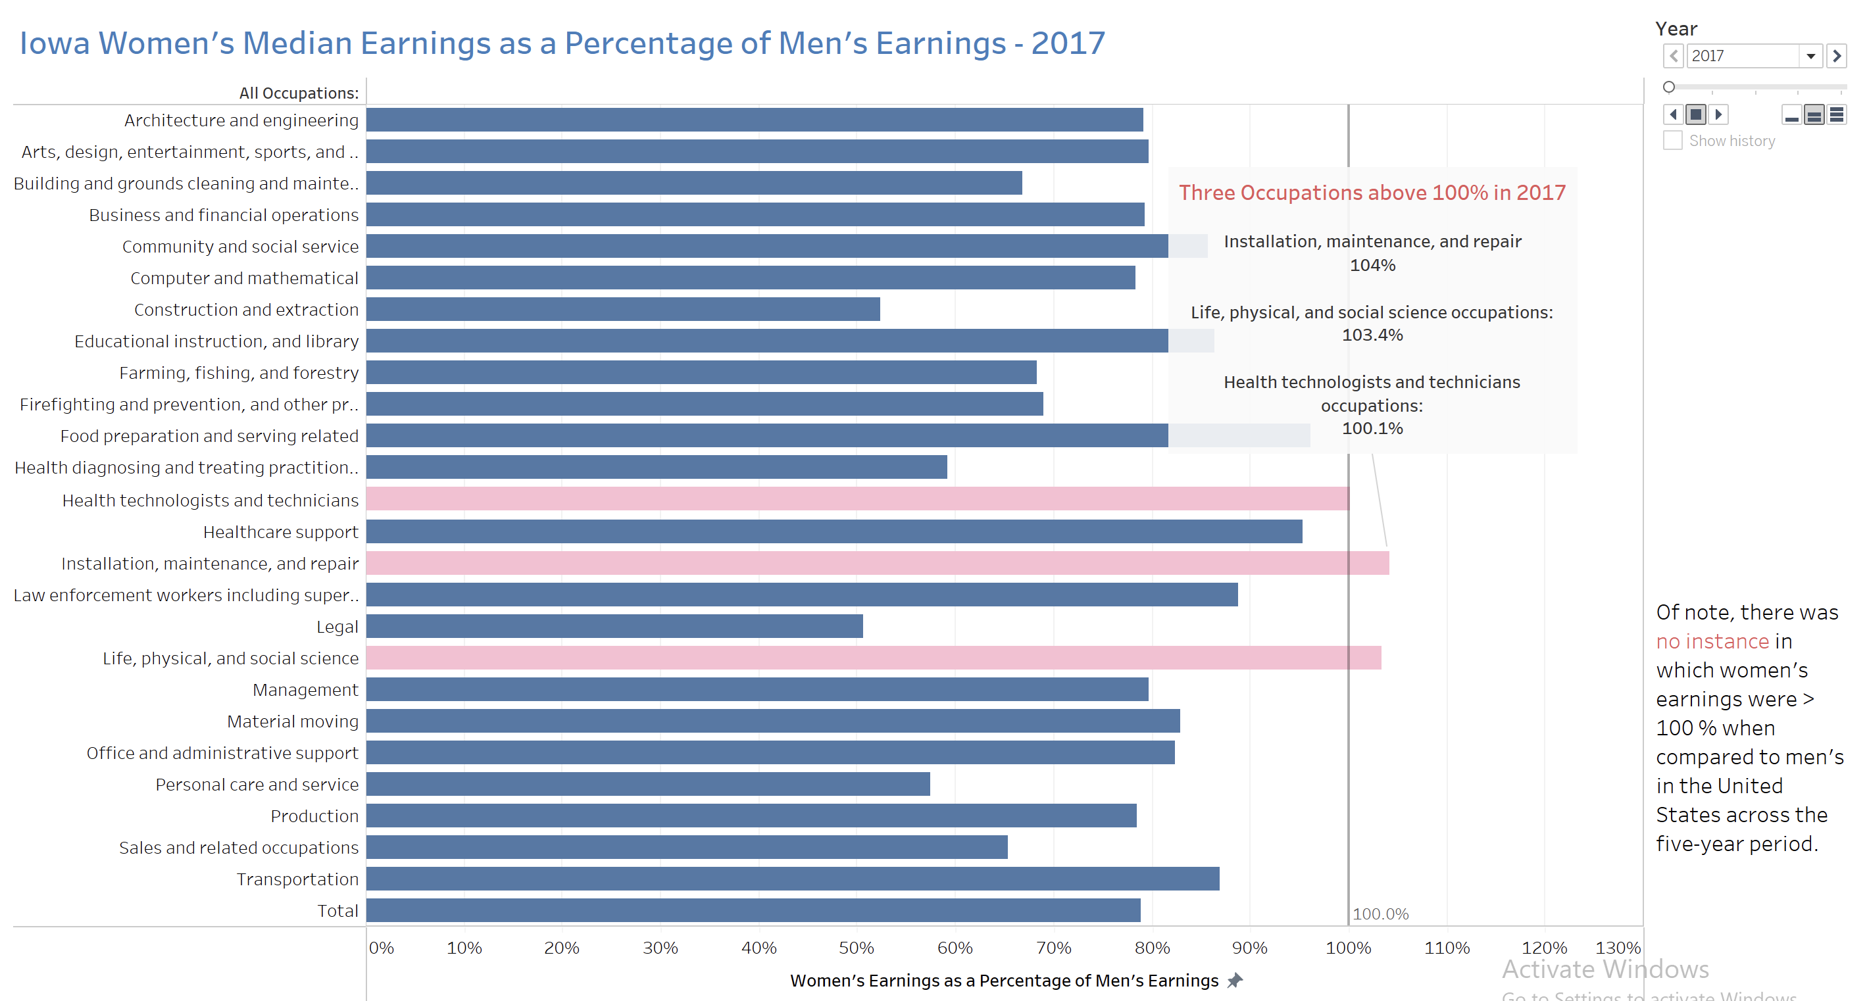

*Figure 9. Iowa women’s median earnings as a percentage of men’s earnings dashboard. Animated bar chart of years 2017 – 2021.*

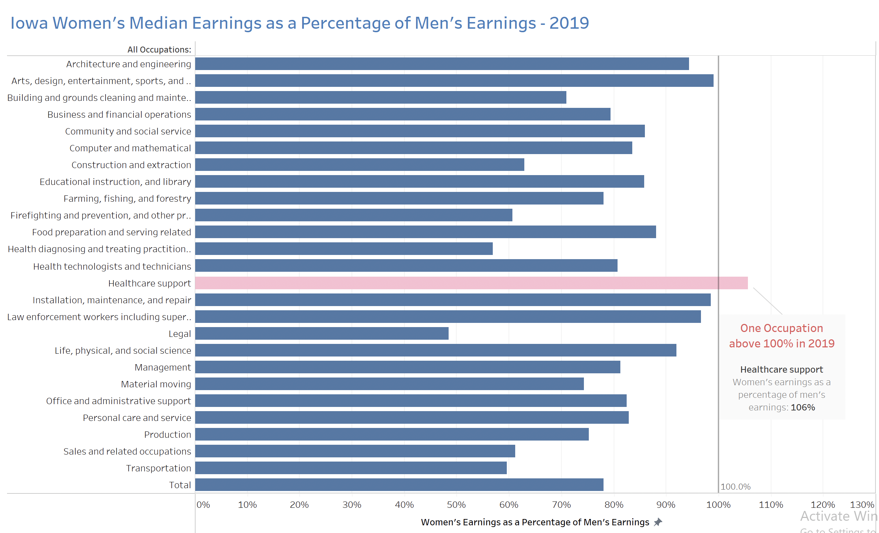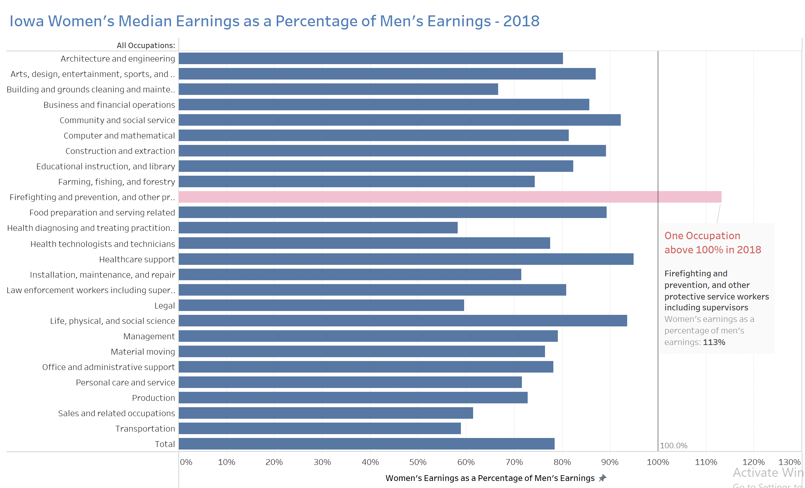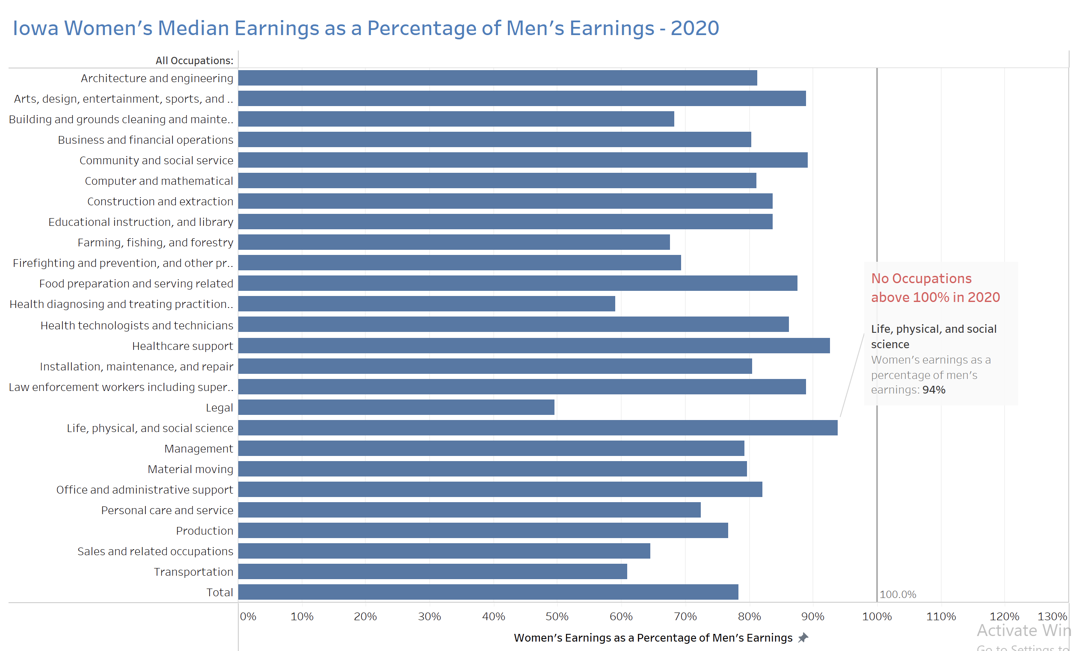

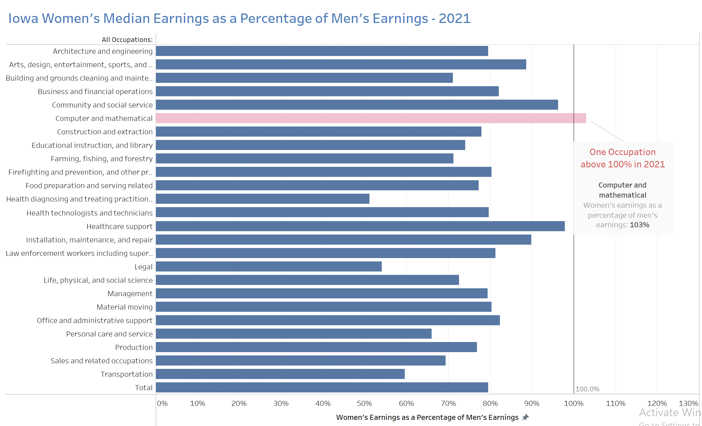

*Figure 10. Occupations above 100% from Figure 9 for (from left to right): 10a) 2018 10b) 2019 10c) 2020 10d) 2021.*

Following this visualization, the dashboard depicted in Figure 11 brings educational attainment into perspective. The tree map and scatter plot are both animated visuals across the five-year period. They provide insight that overall, there is a greater percentage of females obtaining further education when compared to males. This provides a direct contradiction to the conclusions in median earnings with females earning, on average, 21% less than their male counterparts in Iowa.

The tree map in Figure 11a illustrates the rates of female to male educational attainment for seven educational markers. Sizing and color of the tree map is determined based on this percentage. In Iowa, women are obtaining master’s degrees at a rate of 133% compared to men, 120% in obtaining associate degrees, 112% in bachelor’s degrees, 107% in less than a year of college, and 100.3% in more than one year of college. There are only two aspects in which females are at a rate below 100% compared to males: 75% as many females as males are obtaining doctoral degrees, and 87% for high school graduation rates.

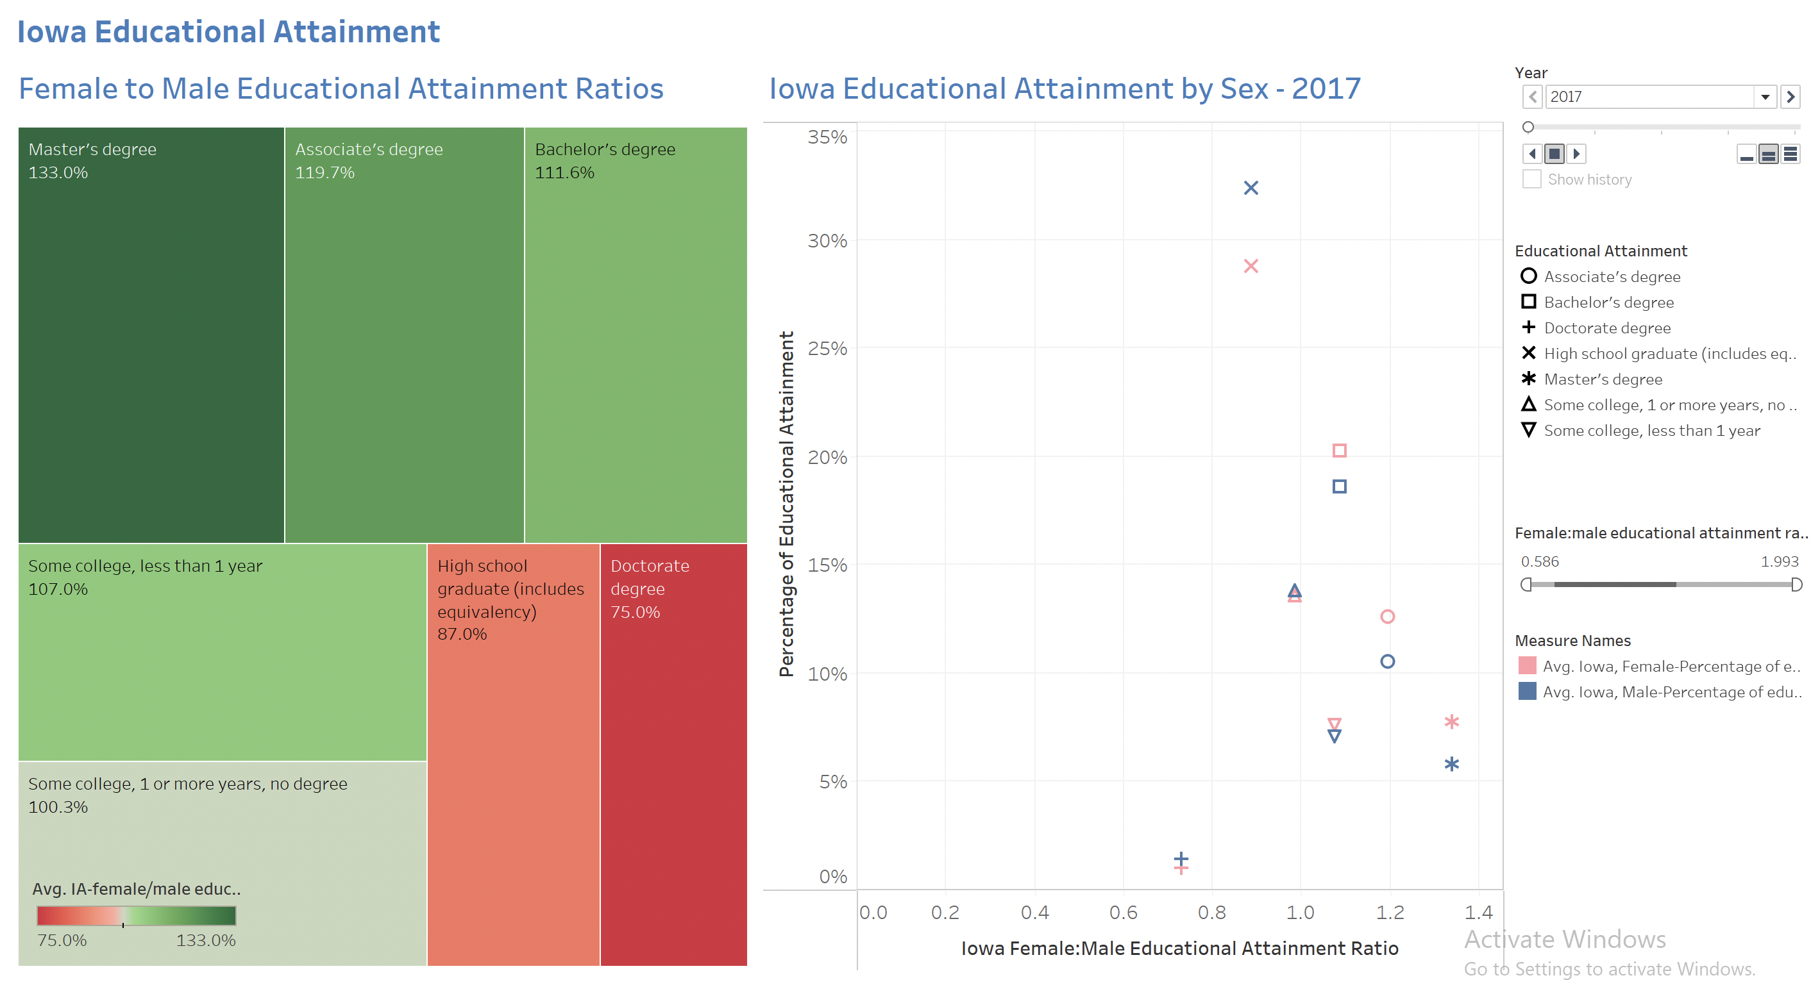The scatter plot in Figure 11b illustrates these attainment rates against the overall percentage of the female and male populations in Iowa. The slider allows to select desired rates. Overall, it seems more women are obtaining more education, and, aside from doctoral degrees, are obtaining more rates of advanced degrees. 20% of the Iowa female population has a bachelor’s degree, and 19% of the male population. 8% of the female population has a master’s degree, contrasting to 6% of the male population. Again, there are only two rates where females are below 100%: high school graduate and doctoral degrees. However, the overall percentage of doctoral degree rates are both very low, at 1.9% male, 1.2% female.

*Figure 11. Iowa educational attainment dashboard (2017 – 2021). 11a) (left) Tree map of female to male educational attainment ratios. 11b) (right) scatter plot of Iowa educational attainment by sex.*

**Discussion**

There are a few limitations with the datasets, including the inclusion of only full-time workers and no subcategories for age groups, as the data collected from the U.S. Census Bureau encompassed the full-time population 16 and over as a whole. For example, the Pew Research Center found that the 2020 wage gap was smaller for workers ages 25 to 34 than for all workers 16 and older, with women earning $.93 for every dollar a man in the same age group earned on average, as has been the case in recent decades (Barroso & Brown, 2022, para. 2).

According to the Census Bureau, the data is based on a sample and is subject to sampling variability. The degree of uncertainty for an estimate arising from sampling variability is represented through the use of a margin of error, although this margin of error was not included in visualizations for simplification. Values represent a 90% margin of error, interpreted roughly as providing a 90% probability that the interval defined by the estimate minus the margin of error and the estimate plus the margin of error (the lower and upper confidence bounds) contains the true value (United States Census Bureau (n.d.)). In addition to sampling variability, the estimates are subject to non-sampling error (United States Census Bureau (n.d.)).

**Conclusion**

Aside from the outliers investigated in these visuals, males are consistently earning more than females in every occupation. This, paired with the higher attainment levels of females, on average, work to bring to light that gender pay gaps are still prominent in Iowa and the United States as a whole. To further extend my analyses, I can investigate relationships of educational attainment as it relates to median earnings to find possible correlations. There are also further factors I could consider in my analyses, including gender discrimination and work experience measurements. Given more time, I would investigate data from other states to get a better sense at how individual states compare. Along with investigating specific age groups, it would be interesting to see how race and ethnicity play a role along with sex.

I have helped to illustrate today’s gender pay gaps through identifying key differences in female and male median earnings and educational attainments. My investigations, paired with increasing trends toward pay transparency, can help to continue to move toward pay equality in the U.S., and I can continue to know my worth as a woman in STEM.

**References**

1. Barroso, A., & Brown, A. (2022, June 8). *Gender pay gap in U.S. held steady in 2020*. Pew Research Center. Retrieved December 10, 2022, from https://www.pewresearch.org/fact-tank/2021/05/25/gender-pay-gap-facts/

2. Trane, G. (2022). *Information Visualization Dataset_Educational Attainment*. United States Census Bureau. Retrieved November 30, 2022, from

https://data.census.gov/table?q=sex&g=0100000US_0400000US19&tid=ACSDT1Y2021.B15002&moe=false

3. Trane, G. (2022). *Information Visualization Dataset_Occupations*. United States Census Bureau. Retrieved November 28, 2022, from

https://data.census.gov/table?q=S2412:+OCCUPATION+BY+SEX+AND+MEDIAN+EARNINGS+IN+THE+PAST+12+MONTHS+(IN+2021+INFLATION-ADJUSTED+DOLLARS)+FOR+THE+FULL-TIME,+YEAR-ROUND+CIVILIAN+EMPLOYED+POPULATION+16+YEARS+AND+OVER&g=0100000US_0400000US19&tid=ACSST1Y2021.S2412&moe=false

4. United Nations. (2022, September 18). *Closing gender pay gaps is more important than ever  | UN news*. United Nations. Retrieved December 10, 2022, from https://news.un.org/en/story/2022/09/1126901#:~:text=For%20every%20dollar%20men%20earn,the%20global%20gender%20pay%20gap.

5. United States Census Bureau (n.d.). Explore census data. Retrieved December 10, 2022, from https://data.census.gov/table?q=sex&g=0100000US